CSA1041- SOFTWARE ENGINEERING

BY- SRI BALAJI.S (192224033)

**1.VOTING SYSTEM USE CASE**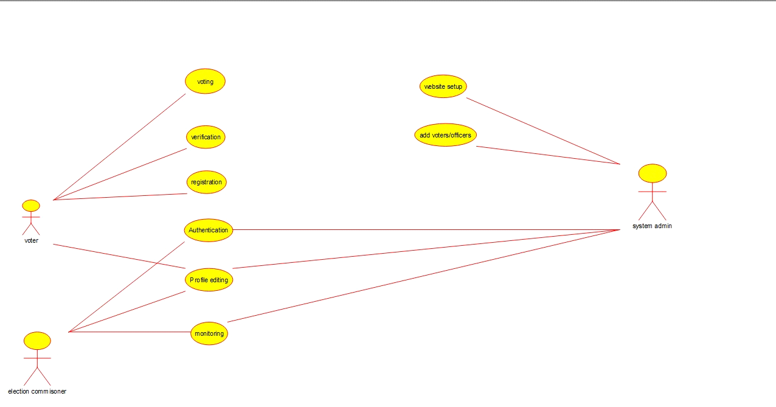

**2.LIBRARY MANAGEMENT USE CASE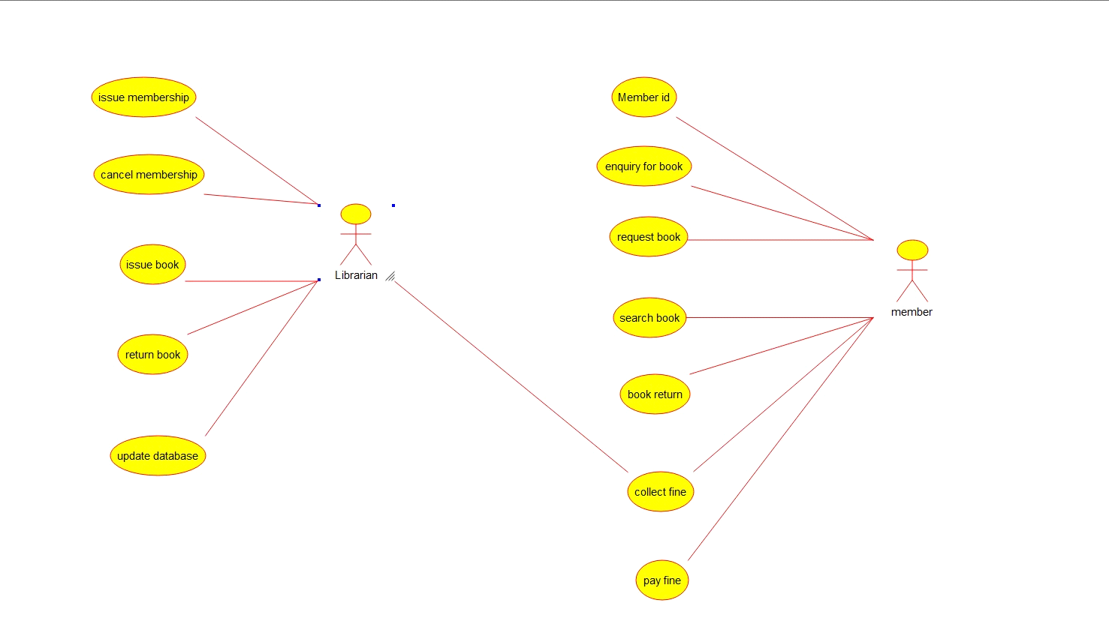3. QUATIENT AND REMINDER FLOWCHAT**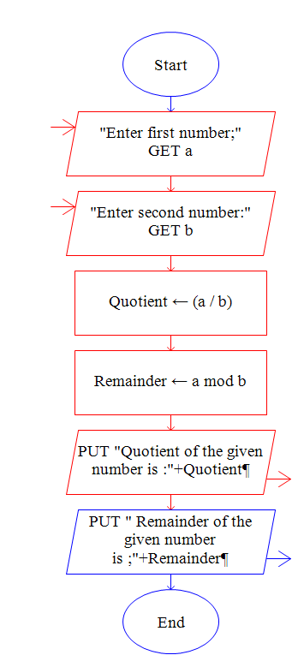

**4**. ONLINE SHOPPING USE CASE

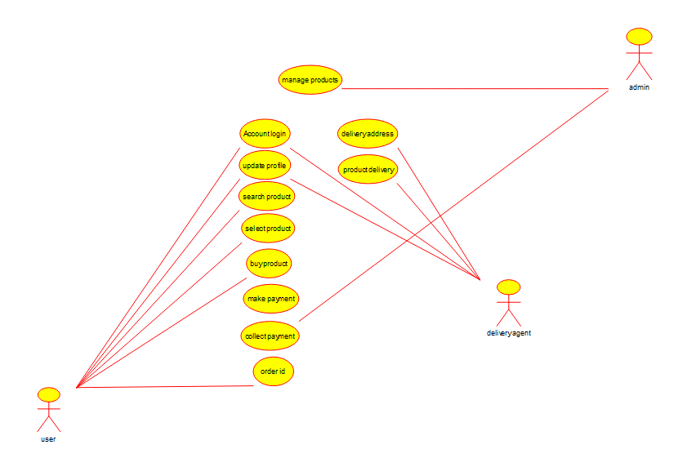

**5.ONLINE RAILWAY RESERVATION SYSTEM USE CASE**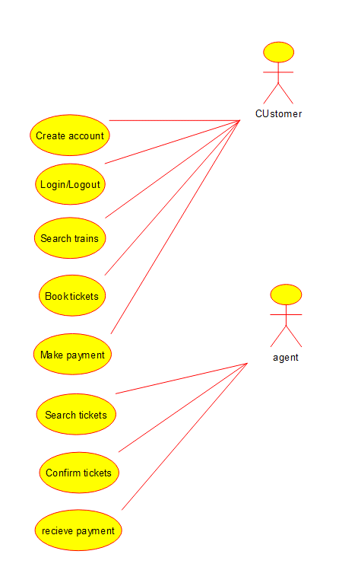

**6.HOSPITAL MANAGEMENT SYSTEM USE CASE**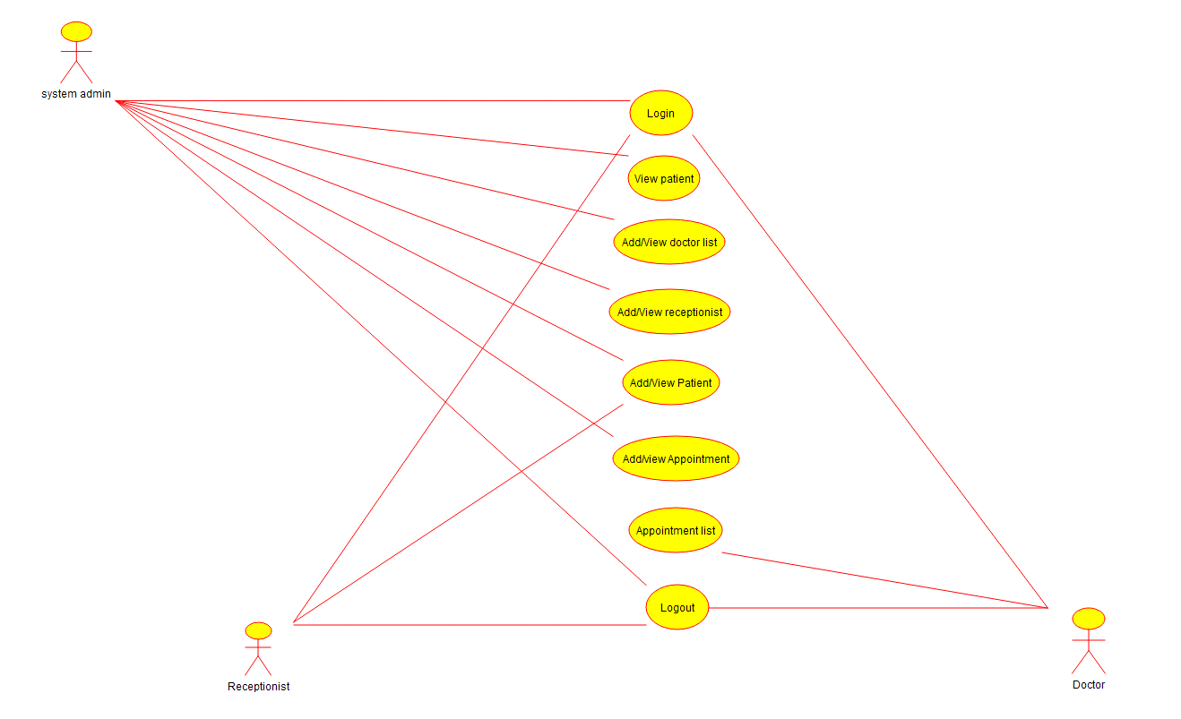

**7.ATM SYSTEM USE CASE**

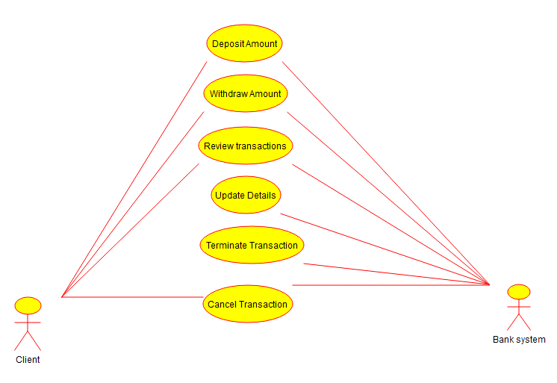

**8. ONLINE COLLEGE MANAGEMENT SYSTEM USE CASE**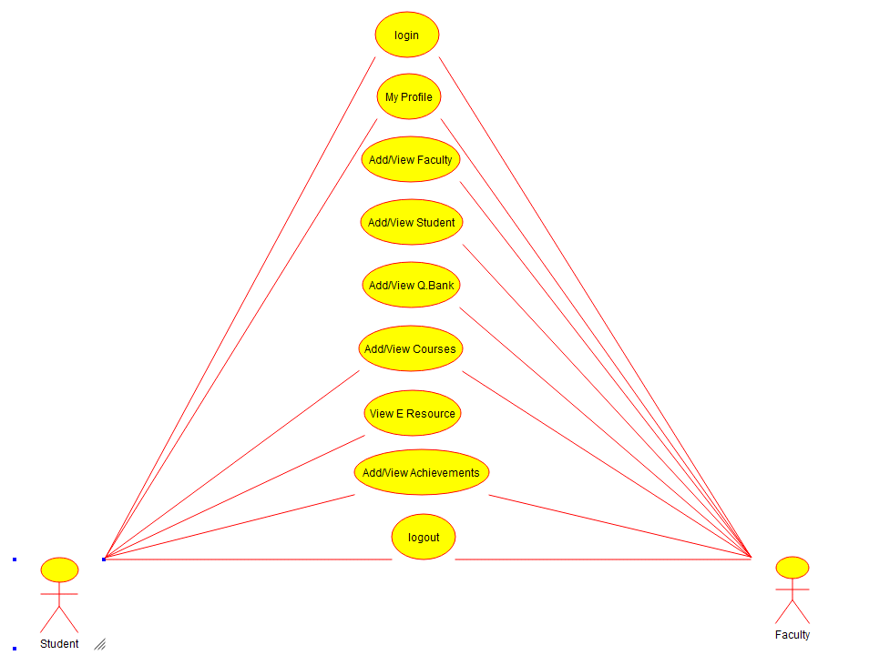

**9. ONLINE AIRLINE RESERVATION USE CASE**

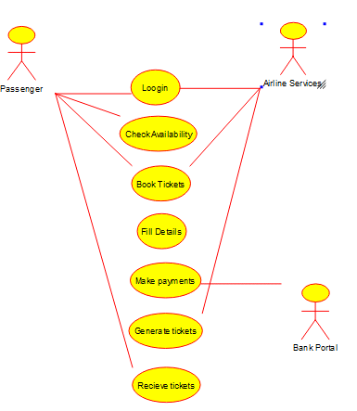

**10.ONLINE AIRLINE RESERVATION CLASS DIAGRAM**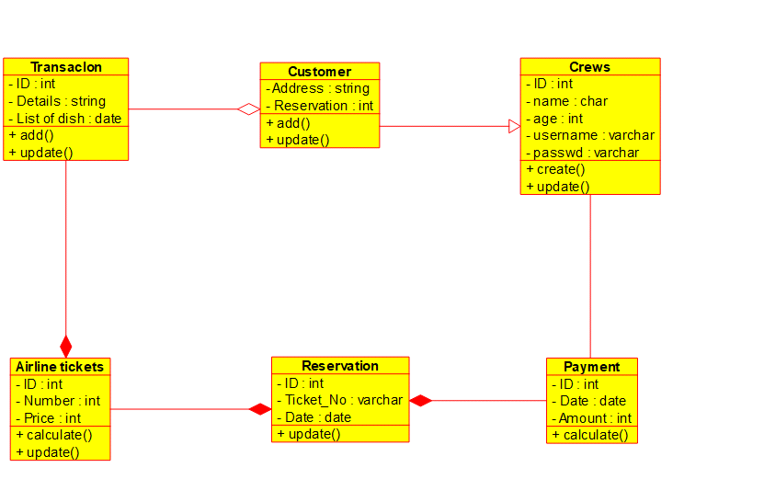

**11. ONLINE VOTING SYSTEM CLASS DIAGRAM**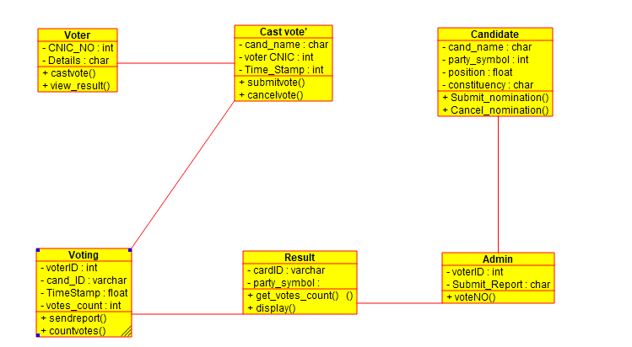

**12. LIBRARY MANAGEMENT SYSTEM CLASS DIAGRAM**

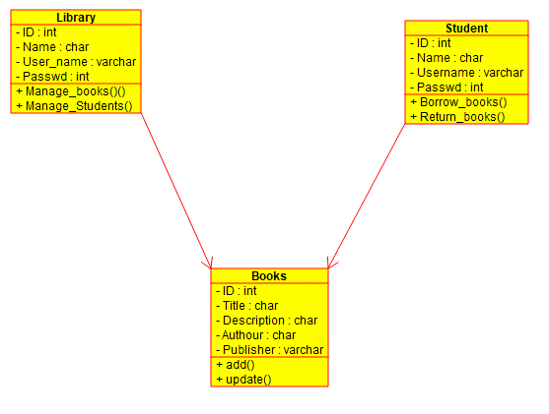

**13.ONLINE SHOPPING SYSTEM CLASS DIAGRAM**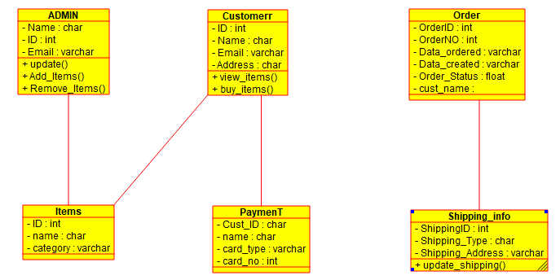

**14.ONLINE RAILWAY REGISTRATION SYSTEM CLASS DIAGRAM**

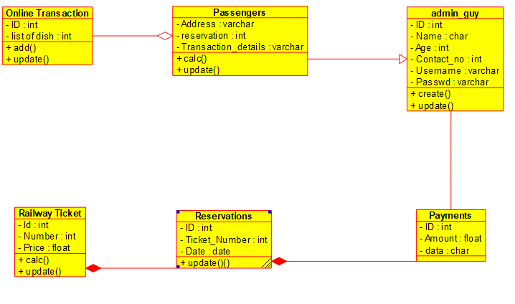

**15. ONLINE VOTING SYSTEM ACTIVITY DIAGRAM**

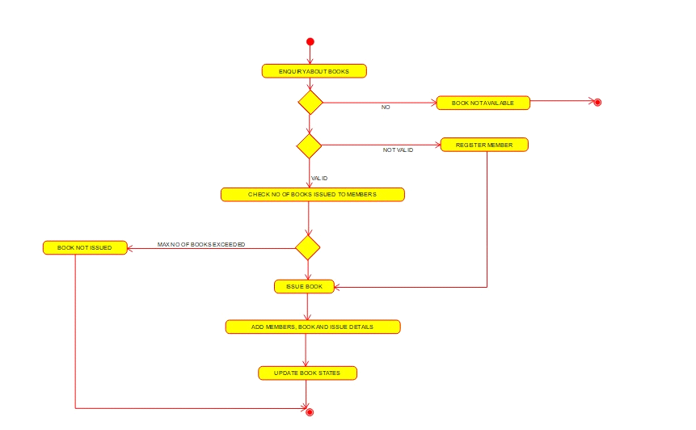

***16.* LIBRARY MANAGEMENT SYSTEM ACTIVITY DIAGRAM**

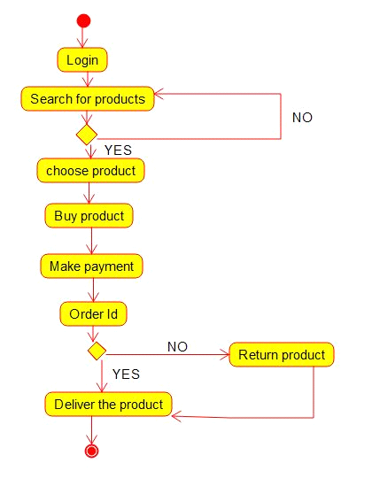**17. ONLINE SHOPPING ACTIVITY DIAGRAM**

**18.ONLINE RAILWAY RESERVATION ACTIVITY DIAGRAM**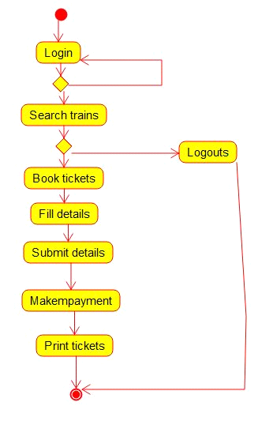

**19.HOSPITAL MANAGEMENT SYSTEM ACTIVITY DIAGRAM**

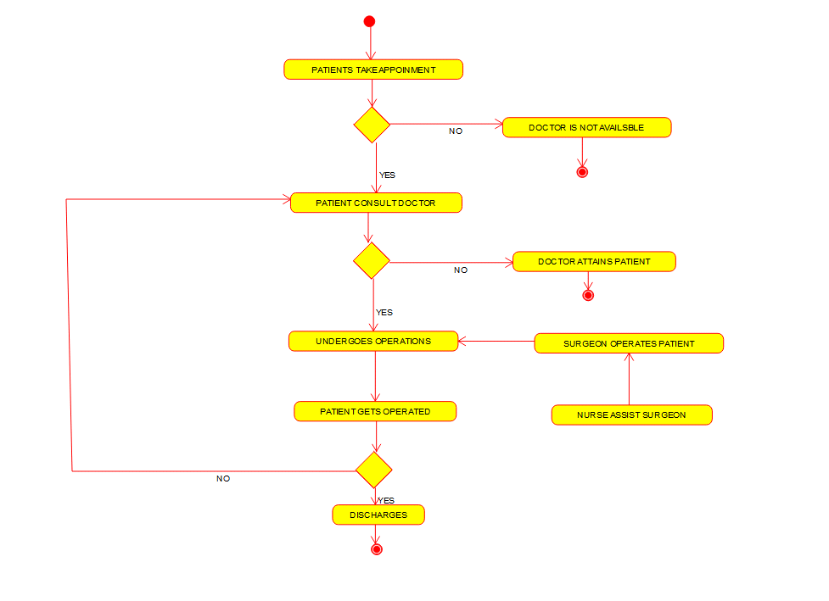

**20.CHECK WHETHER IT IS PALINDROME OR NOT PALINDROME**

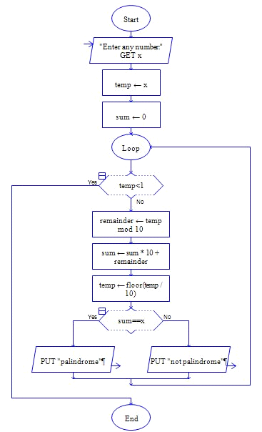

**21. CALCULATE FIBONOCCI SERIES**

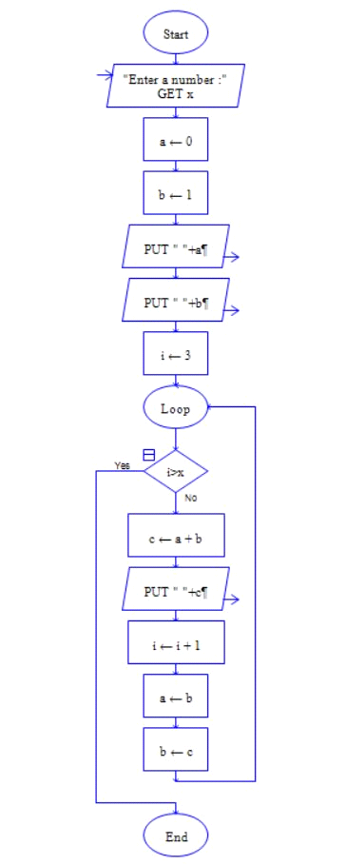

**22.SWAP TWO CHARACTERS**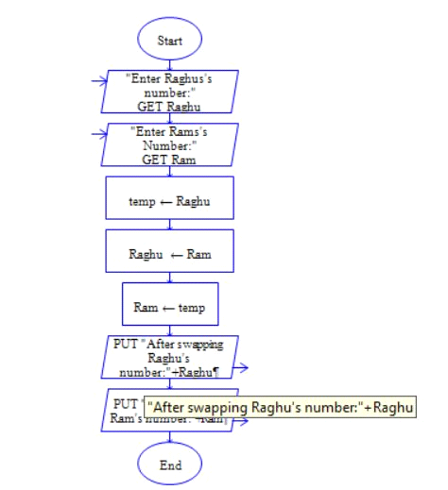

**23. CHECK THE NUMBER IS PRIME OR NOT**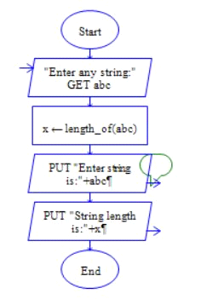

**24. DISPLAY THE LENGTH OF THE STRING**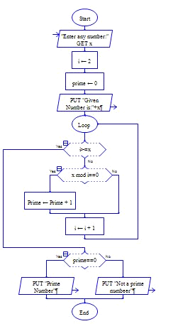  
  
**26.HOTEL MANAGEMENT USE CASE**  
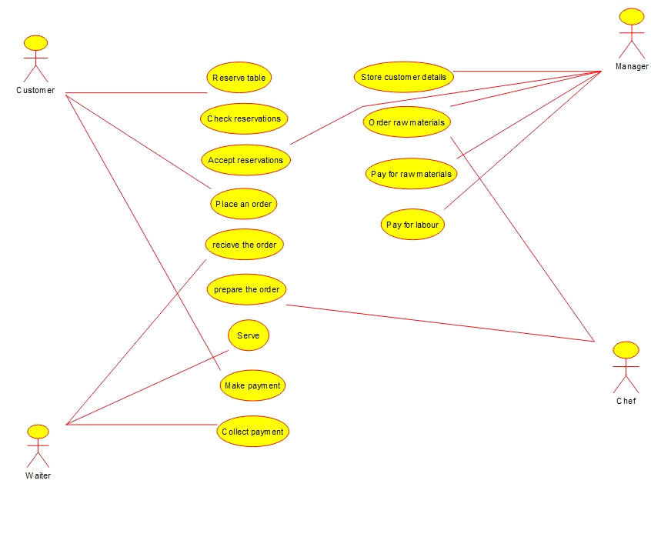

**27.**

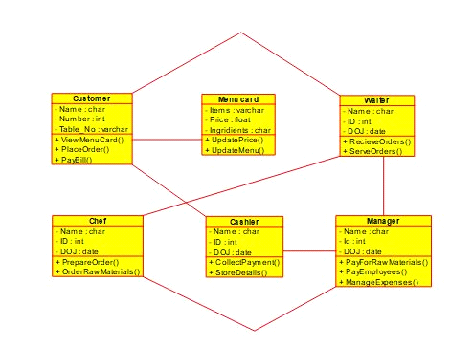

**28.**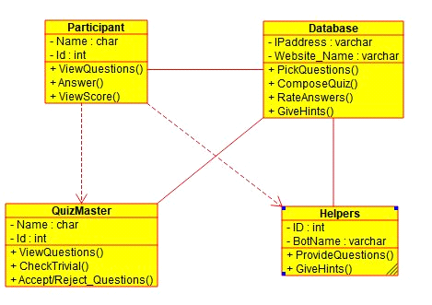

**29.**



**30.**

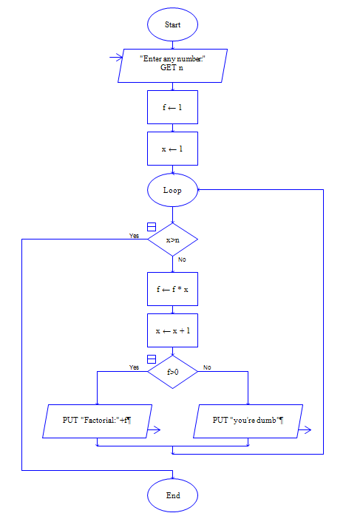

**31.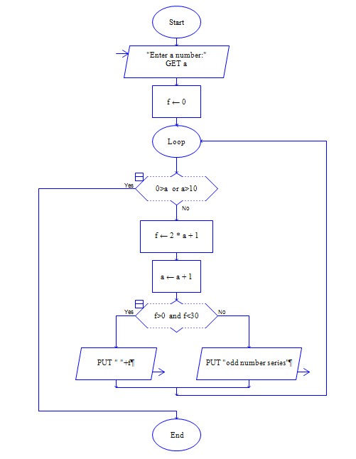32.**

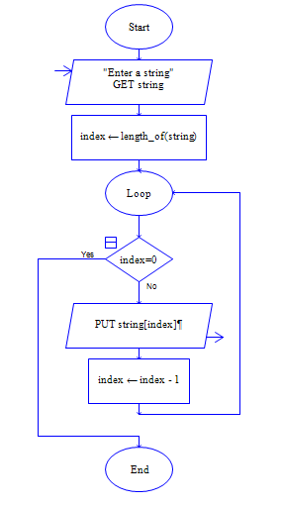

**33.**

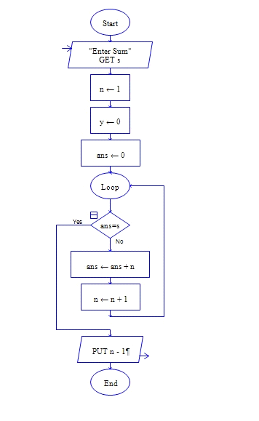

**34.**

**35.**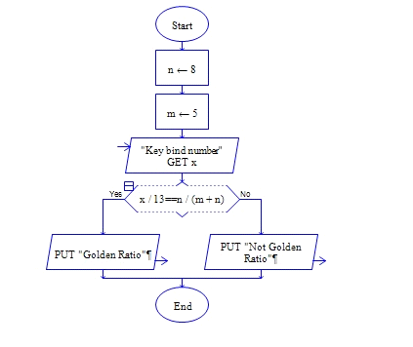

**36.**

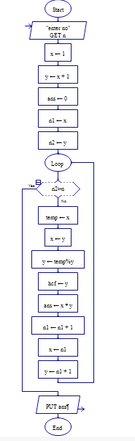

**37.**



**38.**

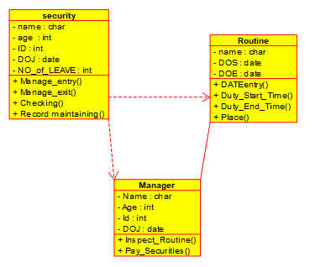

**39.**